**The Ark Documentation.**

**Search for an existing subject.**

Log in and select your study.

Once you have chosen your study we will see the following functions. Click the subject function.

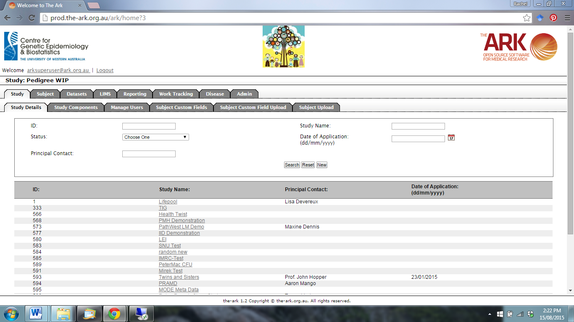

The following page will appear.

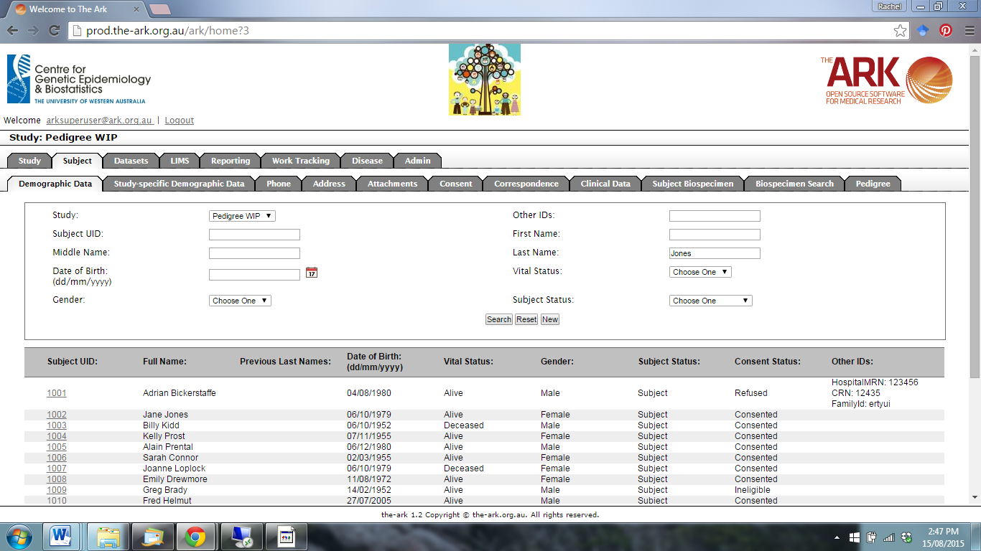

You can search for an existing subject by:

1. Searching for the Subject UID or other ID
2. Searching for the subject name (First Name or Last Name)
3. Date of birth
4. Gender
5. Vital status
6. Subject status

The search results will be returned below the search boxes. You can view the subject’s record by clicking on the Subject UID number.

